The second lab compounded further the use of Verilog, and ModelSim. Using logic, a 4 to 16 decoder was designed, and implemented into the HDL. The circuit is then simulated.
Lab 2
Thomas Cooper
Computer Engineering Major

INTRODUCTION
Adecoder circuit can be easily crafted with Verilog. The second lab compounds previous lessons and intensifies understanding of a decoder. The tasks outline the creation of a 4 to 16 decoder comprised of basic logic gates.

Task #1
The first task requires the creation of the schematic for the decoder. The process is much simpler if a truth table is generated first. With the inputs and the outputs mapped out, a diagram can be created quickly, as there are only two levels of logic.
The lab did not specify what specific gates were required, nor did it specify the specific output. A combination of AND gates and inverters were used in the construction. As well, a one-hot output was selected.

Task #2
With the completion of the first task, next, the Verilog model is written in ModelSim. The task provided freedom to choose the method for describing the model. For lab 2, the output was made to be 16 bits wide, and the output was each assigned a unique state of the inputs. Four standard inputs were used, and were compared using the logical operator &.

Task #3
Next, a simple testbench is created so that the circuit can be simulated and verified. In the testbench, the decoder is instantiated and assigned inputs and outputs. The state of the inputs is progressed every 10 nanoseconds in the same fashion a truth table would increment its inputs. Last, the HDL is instructed to monitor the state of the inputs and outputs.

Task #4
With the decoder and the testbench completed, the circuit can be simulated and verified. First the code is compiled, and once free of any errors, the simulation can begin. The simulation is run for 170 nanoseconds using ModelSim.

Task #5
All of the inputs and outputs are placed within the wave window so their states can be displayed. The fifth task instructs to capture the wave form.

Task #6
Task six instructs to analyze the results to ensure that the model is fully verified.

Task #7
Finally, the lab states for students to contrast between the two models employed. One, the physical drawing of the schematic, and two, the HDL written model. Advantages and disadvantages should be listed for each.

Results
The purpose of the lab was achieved as the decoder circuit was successfully created and fully realized. The physical schematic created, and all code properly compiled, and simulated.

Task #1
The schematic for the decoder was a simple process with the beginning step of creating the truth table to map the inputs and outputs. When the states are listed and organized in the fashion with which they need to be wired, it is very easy to extrapolate how the circuit needs to be laid out.
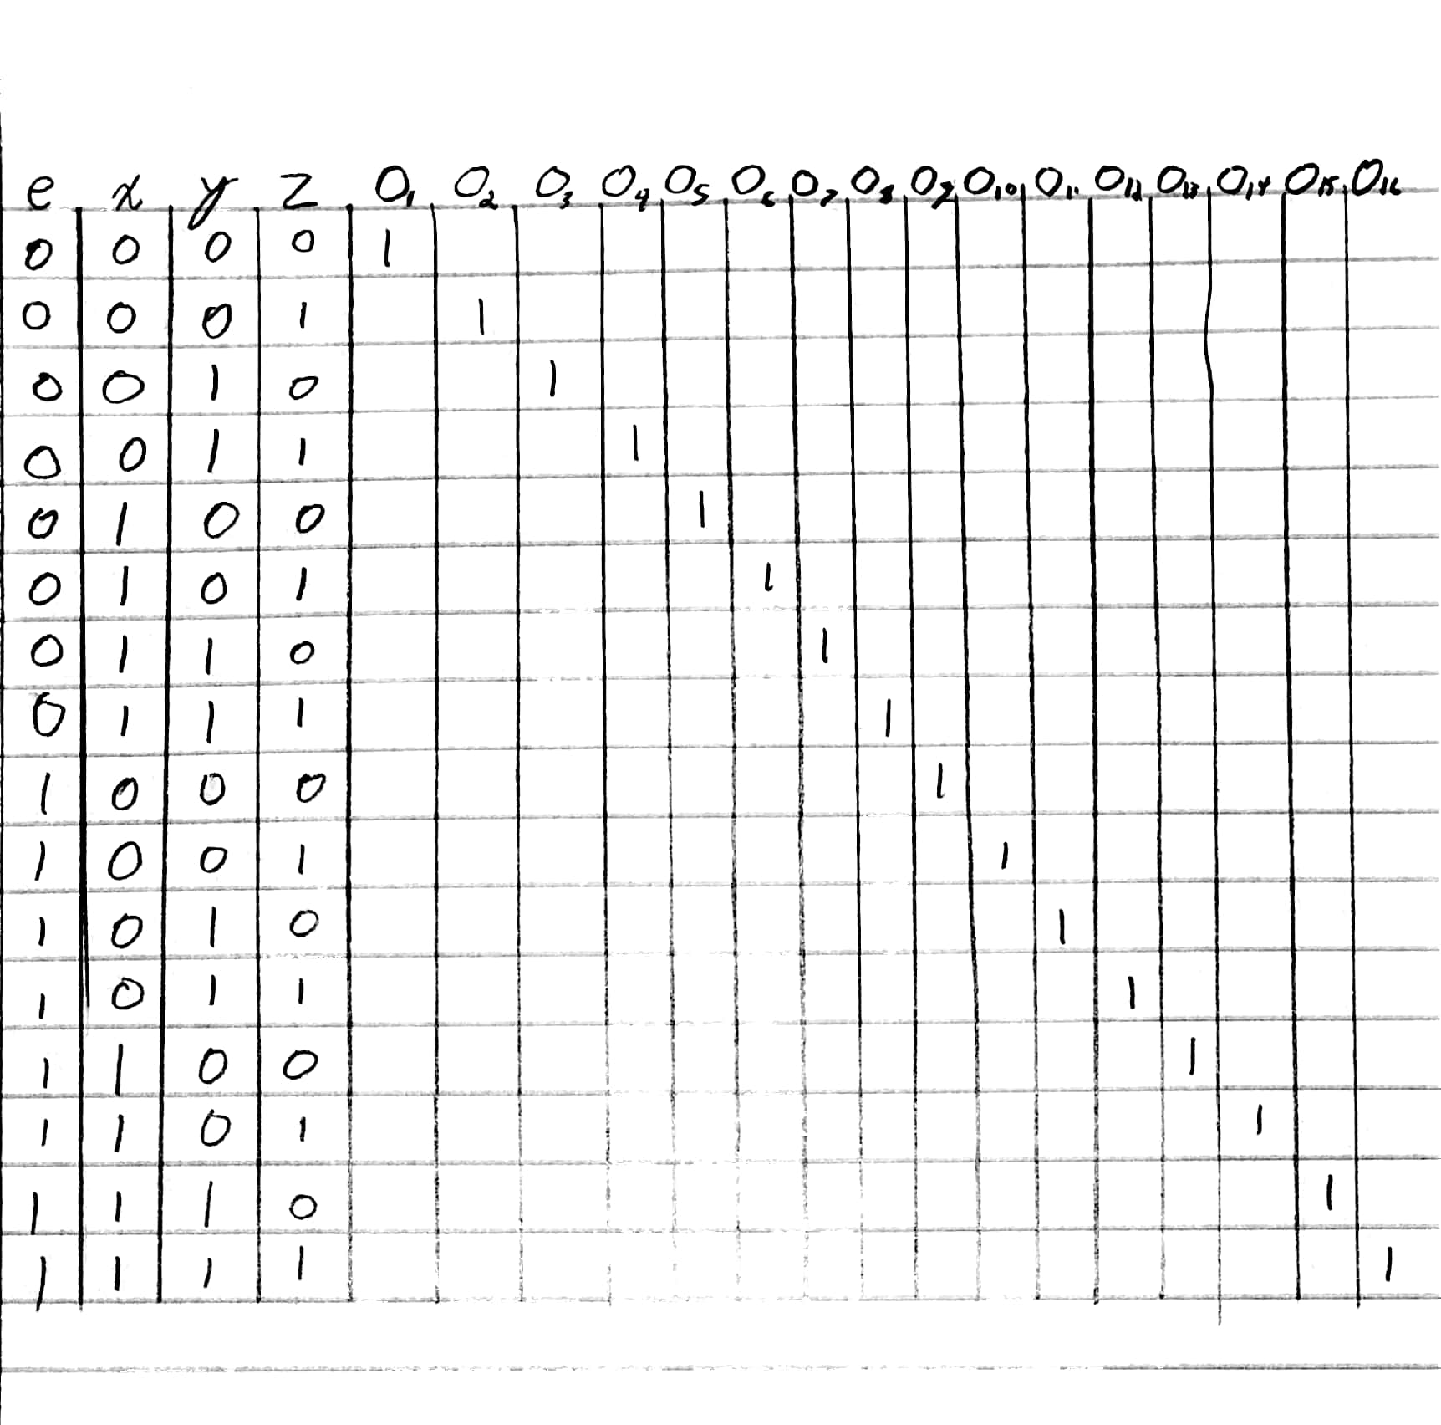
Figure 1 The truth table for the 4 to 16 decoder

The inputs are labeled x, y, and z with an e enable. The outputs are labeled o with their corresponding numerical value attached.
AND gates, and inverters were used for the logic. All of the gates were laid out, and the inputs were attached according to their respective binary value.
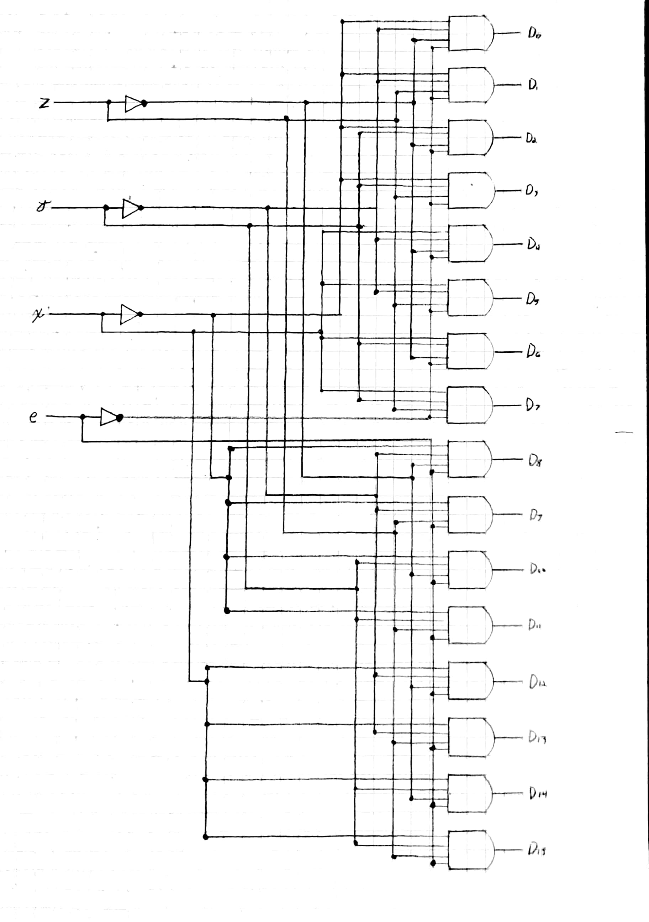
Figure 2 actual 4 to 16 decoder schematic

Task #2
Using the same truth table created for the first task, it is easy to describe a Verilog model of the circuit. The state of the inputs can be plainly translated to the model, and assigned to their respective outputs.
module decoder(o, e, x, y, z);
input e, x, y, z;
output [15:0]o;
assign o[0]= ~e & ~x & ~y & ~z;
assign o[1]= ~e & ~x & ~y & z;
assign o[2]= ~e & ~x & y & ~z;
assign o[3]= ~e & ~x & y & z;
assign o[4]= ~e & x & ~y & ~z;
assign o[5]= ~e & x & ~y & z;
assign o[6]= ~e & x & y & ~z;
assign o[7]= ~e & x & y & z;
assign o[8]= e & ~x & ~y & ~z;
assign o[9]= e & ~x & ~y & z;
assign o[10]= e & ~x & y & ~z;
assign o[11]= e & ~x & y & z;
assign o[12]= e & x & ~y & ~z;
assign o[13]= e & x & ~y & z;
assign o[14]= e & x & y & ~z;
assign o[15]= e & x & y & z;
endmodule
Figure 3 Verilog HDL model for 4 to 16 decoder

The output is labeled o, and is set 16 bits wide with e representing the most significant digit. The logical operators &, and ~ are used to compare AND, and NOT.

Task #3
The creation of the testbench allowed the model to be tested. The decoder was instantiated as dec, and the port list is defined with the output first, o1, followed by the inputs, e, x, y, and z. The state of the inputs is then incremented in truth table fashion every 10 nanoseconds. Last, the state of the input registers, and the output wires are set to be monitored.
`timescale 1ns / 1ns

module testbench;
reg e, x, y, z;
wire [15:0]o1;

decoder dec(o1, e, x, y, z);
initial
begin
#10 e=0; x=0; y=0; z=0;
#10 e=0; x=0; y=0; z=1;
#10 e=0; x=0; y=1; z=0;
#10 e=0; x=0; y=1; z=1;
#10 e=0; x=1; y=0; z=0;
#10 e=0; x=1; y=0; z=1;
#10 e=0; x=1; y=1; z=0;
#10 e=0; x=1; y=1; z=1;
#10 e=1; x=0; y=0; z=0;
#10 e=1; x=0; y=0; z=1;
#10 e=1; x=0; y=1; z=0;
#10 e=1; x=0; y=1; z=1;
#10 e=1; x=1; y=0; z=0;
#10 e=1; x=1; y=0; z=1;
#10 e=1; x=1; y=1; z=0;
#10 e=1; x=1; y=1; z=1;
end
initial
$monitor($stime,, e,, x,, y,, z,, o1);
endmodule
Figure 4 Testbench to simulate the decoder model.

Task #4
The circuit is compiled, and tested. The state of the inputs are planned out in the testbench, and the simulation is ran for 170 nanoseconds. A truth table is created in the output.

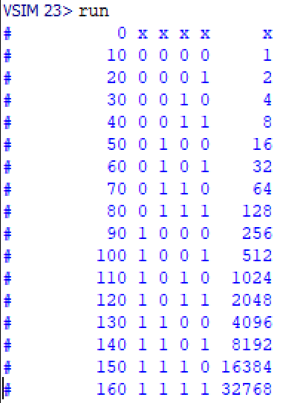
Figure 5 Truth table of the simulation

Referring back to figure 4 from task four, line 5, the bits are defined 15:0 which appears backwards, however it places the enable, or input e as the most significant bit. Looking at 1000000000000000 is equivalent to 2¹⁵, or 32,768 in decimal. The state of the inputs are run in numerical order.

Task #5
Once the simulation has been run, the waveform can be generated. The wave does not reflect the truth table exactly, as the outputs are cascading up from the lower left to the upper right.
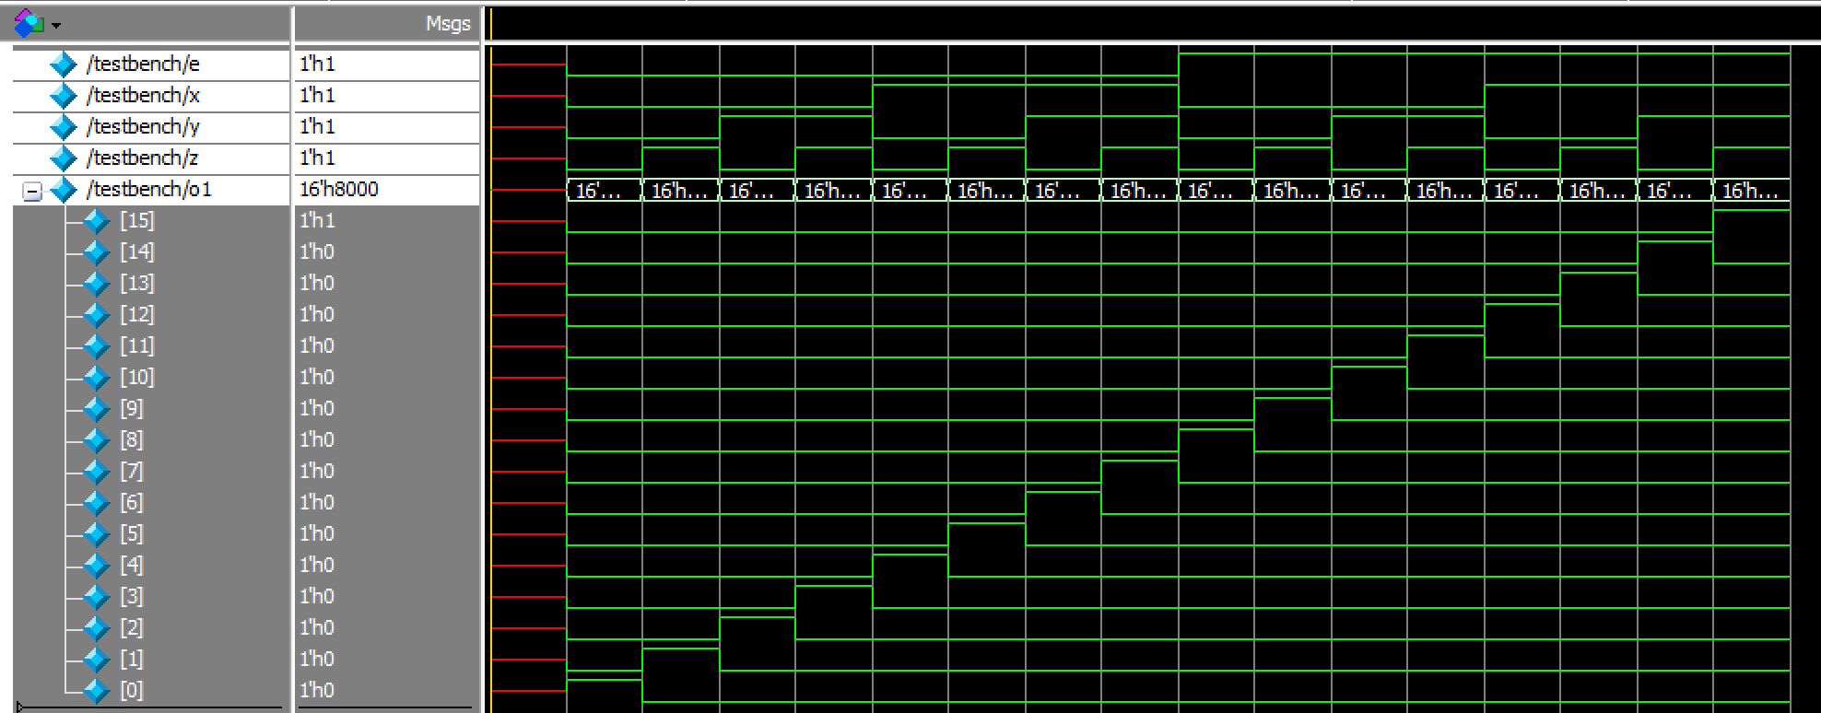
Figure 6 Waveform of decoder with e as MSB

The bit assignment can be reversed so show an output order that cascades down to the right, however this places the MSB as z.
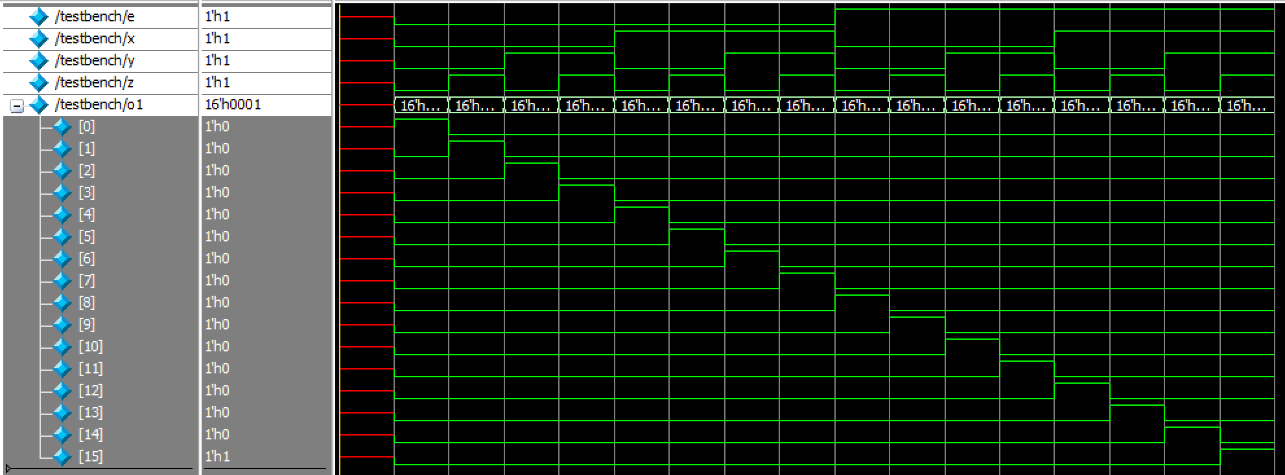
Figure 7 Waveform of decoder with z as MSB

Task #6
Analyzing the circuit only requires that all 16 different input states are tested. The decoder is only a combinational circuit, with 4 inputs, and 16 outputs. The waveform shows a progression of every state of the inputs, and every output has outputted once which is typical of a decoder. The generated truth table from the fourth task also shows that every combination of input has been tested.

Task #7
Hand drawing the schematic allowed the decoder to be easily conceptualized. Visually tracking how the inputs are dispersed amongst the outputs is key. However, an advantage with the Verilog model, it is possible to demonstrate the proper functionality of the circuit. This is a disadvantage for the picture, as it cannot output, and it is up to the interpreter to determine if the circuit is functional.
References
- Provided class slides

 

